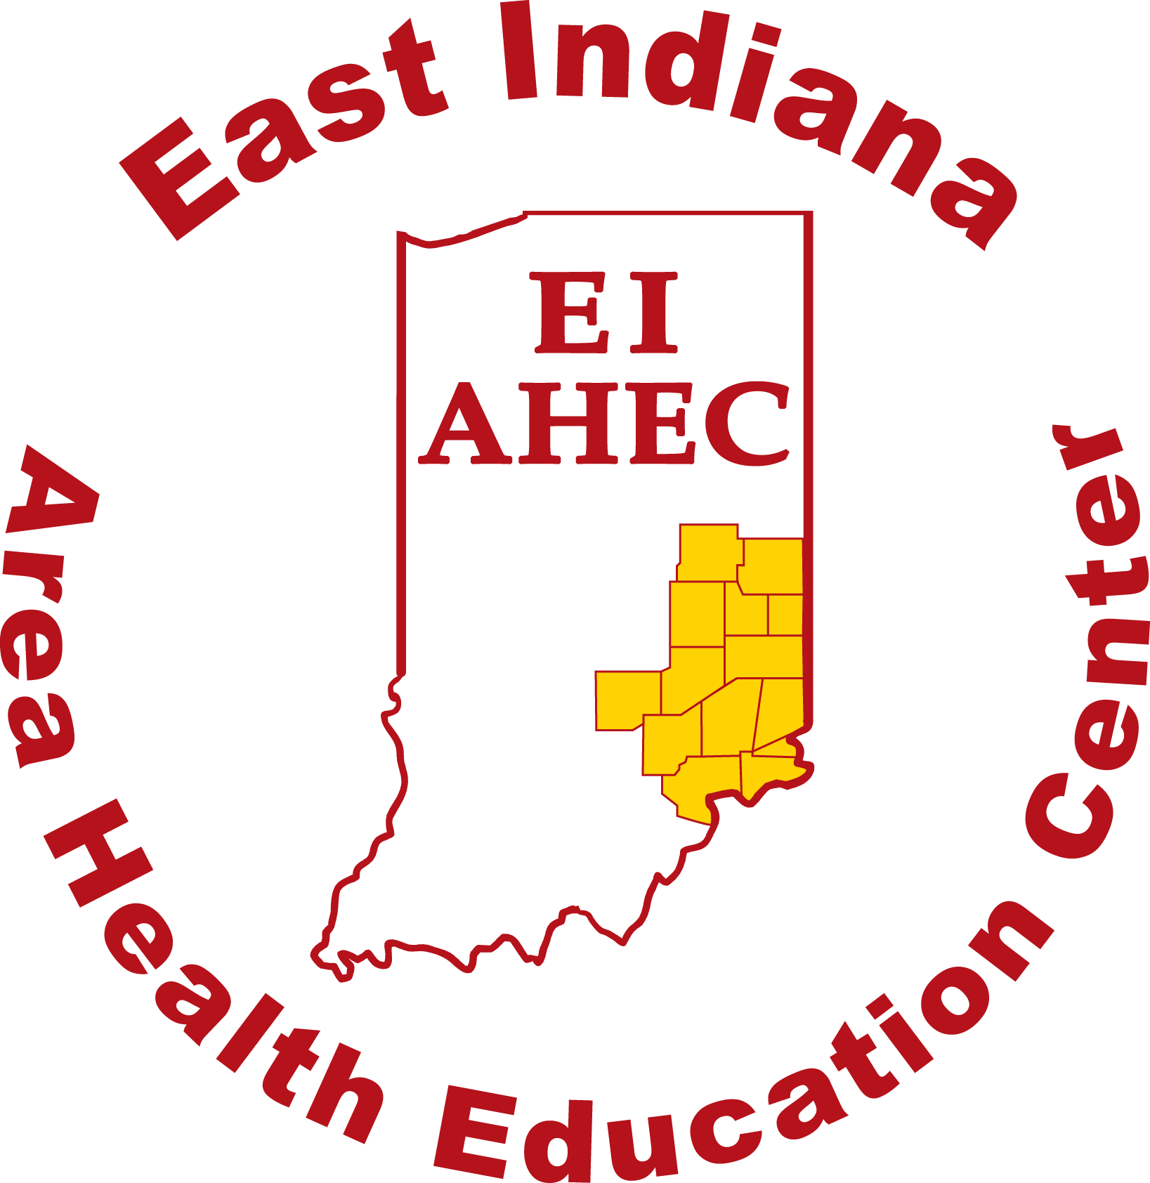
East Indiana Area Health Education Center (EI-AHEC)
2022-2023 Mini-Grant Information Sheet and Application

East Indiana AHEC works to improve health by recruiting, educating, and retaining healthcare professionals for rural and medically underserved communities in our eastern and southeastern Indiana service area that includes Bartholomew, Dearborn, Decatur, Fayette, Franklin, Henry, Jennings, Jefferson, Ohio, Ripley, Rush, Switzerland, Union, and Wayne Counties. We are one of nine regional AHECs in Indiana coordinated by the Indiana AHEC Network office located at the IU School of Medicine.

We are pleased to announce our 2022-2023 mini-grant program. Awards of up to $2,500 will be made to community partners in our region to support programs focused on one of three types of learners or participants as described below.

Goal A – Health Careers Awareness for Pipeline / Pre-Health Careers Students
Support for learning opportunities that improve awareness and skills around health careers opportunities and health careers college / training program success for high school students and pre-health professions undergraduates in our region, particularly those from under-represented minority, disadvantaged, rural, and medically underserved backgrounds.

Goal B - Health Professions College Students
Support for learning opportunities that utilize hands-on experiences or real-world/community settings to build health professions students’ skills and competencies necessary to improve health care quality and provide team-based care in rural and underserved settings with an emphasis on primary care.

Goal D - Practicing Health Professionals
Support for continuing education / professional development that builds practicing health professionals’ skills and competencies necessary to improve health care quality and provide team-based care for rural and underserved settings and populations.

Mini-grant project proposals should target one of the groups described above. A proposal for Goal B health professions college students or Goal D practicing health professionals must also connect to one or more of these national AHEC core topics:
- Interprofessional Education and Practice
- Behavioral Health Integration
- Addressing Social Determinants of Health
- Developing and Practicing Cultural Competency
- Practice Transformation (Quality Improvement, Population Health, PCMH, etc.)
- Addressing burnout / resilience / mental wellbeing for clinical staff
- Training and development of paraprofessionals and Community Health Workers
- Telehealth and virtual learning / simulation tools

2022-2023 Mini-Grant Timeline

- Applications Open – August 2022 (Rolling application process for 2022-2023 with open applications until all budgeted grant funds are awarded. Expect an award decision within approximately two weeks of application submission.)
- Project Implementation Period – August 2022 – May 2023
- Reporting & Financial Documentation Due – May 12, 2023
Financial Requirements and Limitations

EI-AHEC mini-grants operate on a reimbursement basis. EI-AHEC will reimburse an organization receiving an award for allowable, budgeted costs of the program upon successful completion of the project, submission of authorized receipts/invoices, and completion of reporting requirements. Matching local funds are required as cost share for EI-AHEC mini-grants at a ratio of $500 local dollars for every $1000 EI-AHEC dollars requested. (A full $2500 award would require a minimum $1250 local match.)

Reimbursement for food, entertainment, promotional items, scholarships, and administrative overhead is not allowed with these grant funds. Local funds used for these types of expenses on a project are also not countable as matching funds.

East Indiana AHEC funds come from subcontracts with the Indiana AHEC Network, IU School of Medicine which receives both federal funds via HRSA AHEC grants and state funds via the Indiana State Department of Health. Accordingly, EI-AHEC mini-grant awardees are subject to Indiana University subrecipient monitoring policies and Federal Regulation 2 CFR Part 200. (https://research.iu.edu/awards-agreements/subrecipient-monitoring/index.html)

Submission Process
- Email application as attachment to jeff.hartz@eiahec.org with “mini-grant” in subject line
- Applications will be reviewed in the order that they are received.
- A committee will review grant applications and consider the following factors:
  - Clear fit with AHEC learner groups, goals, and core topics
  - Clear plan to have participants complete AHEC evaluations
  - Reasonableness / likelihood of full project completion given COVID-19 circumstances
  - If applicable, previous organizational performance around meeting financial, reporting, and evaluation requirements when partnering with East Indiana AHEC
  - Extent to which proposed project is interprofessional in nature (if Goal B or Goal D)

Project Completion

Successful applicants are expected to complete three steps to fulfill grant reporting and evaluation requirements by May 12, 2023.

- Individual participants/learners complete Indiana AHEC evaluation forms
- Submit expense receipts or similar documentation for reimbursement
- Grantee contact person completes brief grant summary report via online form

Grant Application Contact

Jeff Hartz, Center Director, East Indiana AHEC 765-251-8551 jeff.hartz@eiahec.org

Potential Applicants are WELCOME to reach out and discuss a grant idea prior to applying!

2022-2023 EI-AHEC Mini-Grant Application Page 1

Project Title and 1-2 Sentence Summary:

2. Which AHEC goal area does your project/proposal address:
☐ Health careers awareness and college success activities for high school students. (Goal A)
☐ Hands-on experiences (simulations, clinicals, fieldwork, etc.) for health professions students. (Goal B)
☐ Professional development / continuing education for current health professionals. (Goal D)
3. Is the organization applying for this grant a 501c3 nonprofit or a government / education entity?
☐ yes ☐ no
EI-AHEC can only issue checks to 501c3s and government or educational entities. If you answered “no” above, an eligible organization must serve as your fiscal agent to handle granted funds. If this is the case, please verify that an organization is willing to serve as your fiscal agent by submitting a letter of support from the fiscal agent org’s board president. This letter of support should include the fiscal agent organization’s tax ID number.. Applications from non-eligible organizations will not be considered without this letter of support.

4. List details about the organization applying:

Organization Name:
Grant Application Contact Person:
Mailing Address:
Phone:
Email:
Tax ID Number:

2021-2022 EI-AHEC Mini-Grant Information Application Page 2

5. Project Description – please provide an overview of the proposed project.
- What activities will take place? • When and where will the project take place?
- Who will your learners / participants be? • What are the expected outcomes?
- If Goal B or Goal D, how does project address an AHEC core topic as outlined on the first page of grant information sheet? (Please focus this explanation on just 1 or 2 AHEC core topics. It is not necessary for a mini-grant to address multiple core topics.)

6. Project Evaluation – please explain your plan to have project participants complete Indiana AHEC Network learner evaluations.
- How many participants will be involved / trained and thus complete evaluations?
- When in the process will you have participants complete evaluations?

East Indiana AHEC can provide you with paper or webform versions of Indiana AHEC learner evaluations. The evaluation is specific to high school students, health professions college students, or current health professionals.
Note that no mini-grant dollars will be paid without a clear plan to collect learner evaluations.

2021-2022 EI-AHEC Mini-Grant Information Application Page 3
7. Project Costs / Use of Funds – please provide an overview of your anticipated grant purchases.

Describe the items you will buy or pay for with these grant funds along with cost estimates. When practical, include/attach evidence for cost estimates such as quotes, order forms, trainer pricing, etc.

EI-AHEC requires a local match of at least 50% of the amount of EI-AHEC grant funds requested.
For example, an application requesting $1000 in EI-AHEC funds would need to have a $500 local match. Include local match funds in the overview of anticipated purchases. Awardees will be asked to provide documentation of local matching funds.

8. Please complete the budget template below, including details of local matching funds (which can include cash or in-kind contributions from your organization or other community partners).

Budget Category | EI-AHEC Grant Funds Request | Local/Partner Cash Matching Support | Local/Partner  In-Kind Matching Support | Total for Budget Line (add across)
Contracted Services (trainers, speakers, etc.):
Education Supplies:
In state/local travel for participants:
Other (briefly explain):
Column Totals  (add down): | (up to $2500)

Local cash and in-kind matching support must add up to at least 50% of the EI-AHEC funds requested.

