AY 2021-22 Family Medicine Clerkship Clinical Preceptor Mini Syllabus
Please note this mini syllabus is subject to change. Please see Companion Canvas site for recent syllabus. Last update 4/28/2021

CONTACT INFORMATION
Statewide Clerkship Director:  Scott Renshaw, MD  Office Phone: 317-278-0330  Email: fmclerk@iupui.edu* | Statewide Clerkship Coordinator:  Miranda Benson  Office Phone: 317-278-0330  Email: fmclerk@iupui.edu*

*Please note: fmclerk email is monitored Mon-Fri during regular business hours. This email address is not monitored on weekends or holidays.

DESCRIPTION/OVERVIEW
NOTE: Given the Covid-19 pandemic, changes may need to be made in the content, delivery, and assessment of the course that are not anticipated. Faculty and course leadership will update students expeditiously if such changes are required.

The Family Medicine Clerkship (FMC) is a required four-week clinical rotation for third-year medical students. It is designed and administered by the Department of Family Medicine at the Indiana University School of Medicine. The FMC provides opportunity to develop knowledge, skills and attitudes required to approach a patient and their diagnoses in the primary care setting.

The clerkship will introduce you to the principles and practice of Family Medicine. You will observe how family physicians provide for the ongoing medical needs of their patients within the context of the family and community setting. You will learn how to focus on discrete portions of a patient’s medical history and physical concerns within the confines of the patient’s total health. You will meet patients who present with acute medical problems, those who are chronically ill, those who may need preventive health education, and those who may simply be seeking the support of their physician to cope with the trials and stresses of everyday life. Most importantly, you will see patients interacting with their personal physician and witness firsthand the therapeutic power of the doctor-patient relationship.

CLERKSHIP GOALS AND OBJECTIVES
The overall goal of the Family Medicine Clerkship is to provide an outstanding learning experience for all medical students. At the completion of the clerkship, students will be able to effectively and competently evaluate a patient and produce a competent history and physical that facilitates differential diagnosis and the development of a treatment plan (Society of Teachers of Family Medicine National Family Medicine Clerkship Curriculum). For the clerkship objectives, see Appendix A.

WHAT’S NEW THIS YEAR
The family medicine clerkship is responsive to and values student concerns and feedback. Based on student comments the clerkship experience has been improved. These changes include:

BASED ON IUSM GUIDELINES
- Final Exam. The final exam is the NBME Shelf Exam.
- Practice Exam. You will have access to the NBME practice exam. You will be given an access code and will be able to work on the practice questions over the course of the second half of the clerkship (see “Rotation Specific Assignments” for your exact dates). This Practice Exam is required.
- Study Day. The day prior to your final exam is an official study day. You are not expected to be in clinic (see “Rotation Specific Assignments” for your exact dates). If the day before the exam is a weekend, that is your study day.
- Musculoskeletal Physical Exams Module. This year the MSK Workshop was cancelled. However, you are still required to log MSK physical exams in MedHub (see Learning Experiences/Requirements below). In order to better assist your learning in the online environment, we have developed 3D rigged videos of the joints, which includes physical movement and the ability to rotate and zoom in/out have been added. Two extra credit points are available for completing a survey.

BASED ON MEDICAL STUDENT FEEDBACK
- Optional Text Book. For additional studies, the clerkship recommends Case Files: Family Medicine (5th edition) by Toy, Briscoe, Britton & Heidelbaugh. You can access at no charge via the Ruth Lilly Medical Library (Links to an external site.). See “What You Will Learn” on the homepage for list of required cases.
- Adverse Childhood Events Module. To help you better understand how to start the conversation with your adult patient, we have created patient encounter video.
- Advanced Motivational Interviewing Module. In order to reduce your work load, the Motivational Interviewing assignment has been changed from a written assignment to a quiz.
- Social Determinants of Health: Health Disparities and the Color of Inequity. This module and project have been expanded to include health disparities faced by people of color.

Please do not hesitate to contact fmclerk@iupui.edu with any questions or concerns or feedback.

LEARNING EXPERIENCES & REQUIREMENTS

Clinical Learning Experiences/Requirements
The majority of your time (4-5 days each week) in the Family Medicine Clerkship will be spent with the assigned community faculty in their office and possibly in the hospital and engaging in other patient care activities. This participation provides students the opportunity for one-on-one involvement with a community-based family physician. Through interaction with the community faculty, as well as the nurses and other health team members, it is anticipated students will also acquire practical knowledge about personnel and other managerial aspects relevant to a group or solo practice.

Focused History & Physical
Within the first seven (7) business days of the clerkship, all students are required to have completed an observed, focused history and physical (this is not a complete history) submitted via the Canvas assignment. This is to be observed by the preceptor and includes only pertinent portions of each. The form is downloaded from the Canvas assignment and requires both the patient diagnosis/reason for visit and preceptor signature. Failure to include both will result in zero points.

Required Clinical Encounters/Skills
Patient Encounter Minimums: The Family Medicine Clerkship provides students opportunities to encounter the many aspects of primary care. To ensure all students are exposed to an adequate breadth of family medicine and progress in their participation in patient care, students are required to record a minimum number of Core Diagnoses.

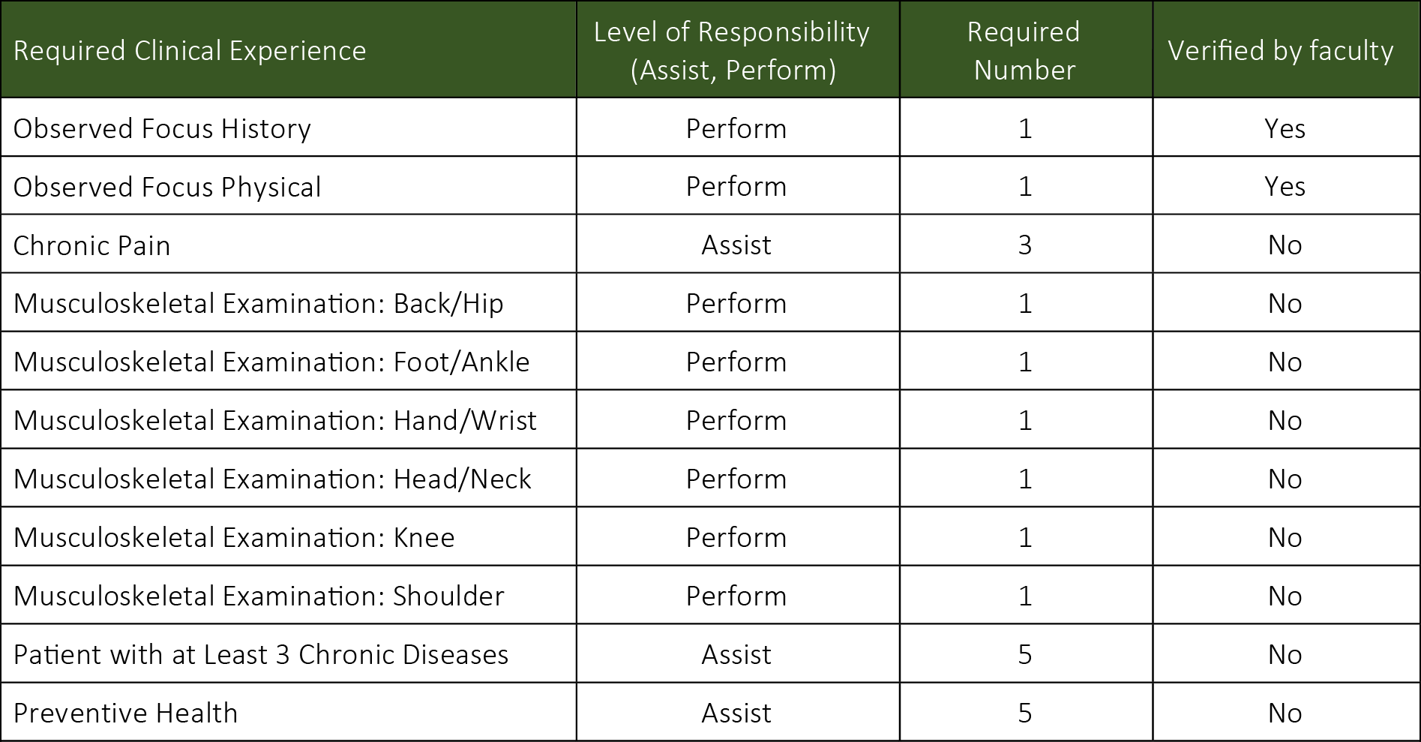

Each clerkship has been assigned specific core clinical skills that require validation. During the Family Medicine Clerkship, students are required to demonstrate skill proficiency in each of the following musculoskeletal (MSK) examinations (see Appendix B).

Non-Clinical Learning Experiences/Requirements
Students will spend any non-clinical time in self-directed learning. This time is to be used to complete all non-clinical assignments as outlined below (Appendix C), in addition to the Aquifer® Family Medicine cases.

GRADING/ASSESSMENT
Final grades are determined by several indicators of student performance on the Family Medicine Clerkship including appropriate and full completion of all assignments/requirements. The grade distribution and grading scale are outlined in the below tables. NOTE: The community faculty preceptor does not assign the student’s final grade.

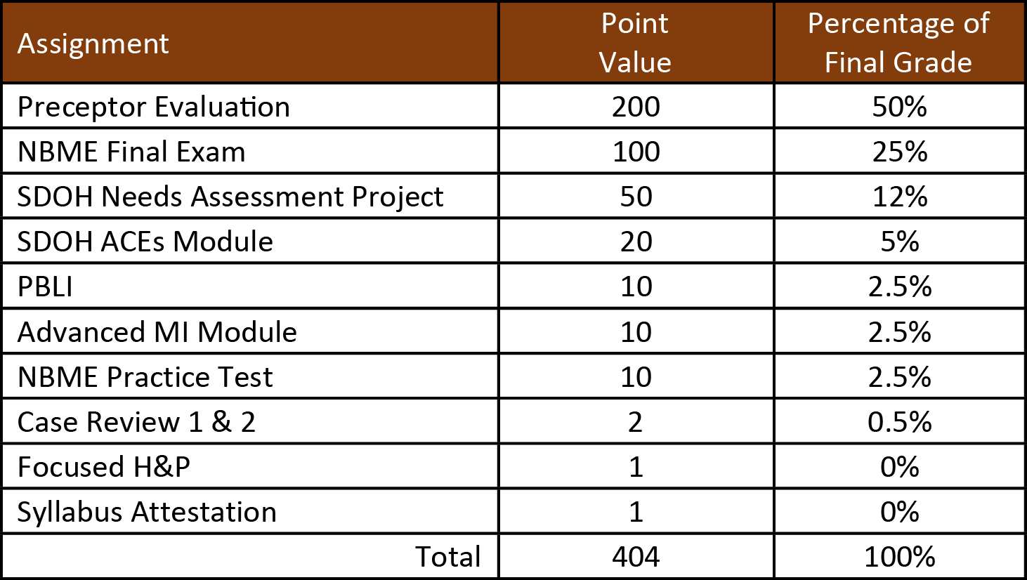

Mid-Clerkship Feedback
During the second week of the clerkship, community faculty will complete the Family Medicine Mid- Clerkship Feedback form. A link will be sent directly to the community faculty via e-mail. The Mid- Clerkship Feedback provides an opportunity for the student and the community faculty to: 1) review the student’s progress; and 2) set goals for the balance of the clerkship. Students should identify areas where assistance is still needed (i.e., what encounters do you still need to cover to meet your minimum requirements), as well as review history taking, physical exam, and problem assessment skills. This is also a good time to review a copy of the community faculty’s evaluation of the student to understand how he or she will be evaluating the student at the end of the clerkship.

Formative Feedback
During the second week of the clerkship, the site director will meet with student to discuss the requirements for successful completion of the clerkship. Students should discuss with the site director anticipated difficulty regarding successful completion of requirements. For example, if the community faculty rarely sees female disorders, the student should talk with the site director to identify other resources to meet the required minimum. Additionally, the site director will identify any concerns with student performance not addressed through the community faculty. Any modifications to the student’s clerkship assignments or areas for improvement will be noted on the formative feedback form.

Completion of this form is required and must be signed by evaluator and student. Students may consult with site directors through telephone conversations and verify receipt of feedback via email.
Documentation will be provided to the main clerkship office for compliance purposes.

CLERKSHIP POLICIES

Attendance
Clerkship attendance is required unless approved by the clerkship director. Students are to consult the Schedule Conflicts, Absences, and Vacations policy and the Adverse Weather procedure prior to completing a request form.

Professionalism
Students must be professional in all communications and interactions. Students must comply with all HIPPA guidelines. Student’s behavior should be professional at all times.

APPENDIX A: Clerkship Objectives

Upon completion of the Family Medicine Clerkship (Y730), learners will…

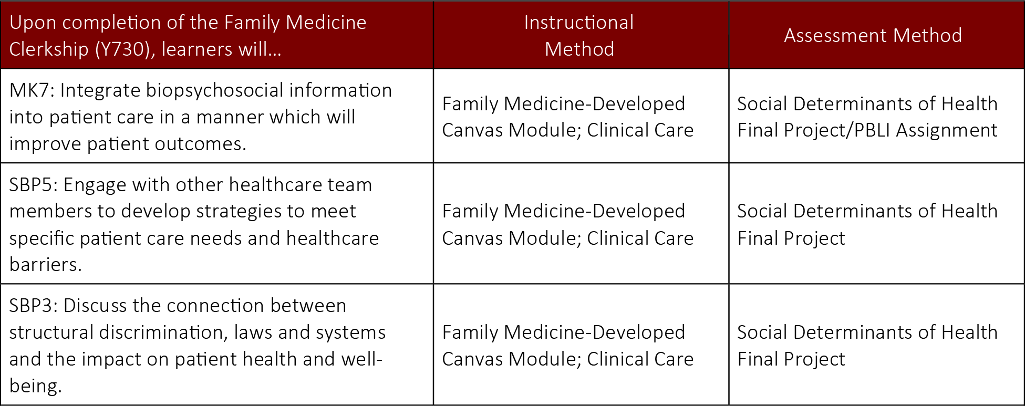

- Demonstrate progressively more accurate, complete, and relevant clinical history-taking and physical examination skills in a variety of settings.
- Justify a prioritized differential diagnosis in a variety of different clinical situations based on data discovered and interpreted from the patient encounter, medical record, and diagnostic testing.
- Integrate data from a clinical encounter to develop a patient-centered plan of care based on up to date scientific information.
- Apply knowledge of normal human structure, function, and development, from the molecular through whole body levels, to distinguish health from disease and explain how physiologic mechanisms are integrated and regulated in the body.
- Explain the causes (behavioral, degenerative, developmental, environmental, genetic, immunologic, inflammatory, metabolic, microbiologic, neoplastic, toxic, and traumatic) of diseases, injuries, and functional deficits affecting organ systems.
- Describe the altered structure and function resulting from diseases, injuries, and functional deficits affecting organ systems*, with an ability to interpret the clinical, histopathologic, laboratory, and radiographic manifestations commonly seen in practice.
- Provide justifications for interventions to diagnose, prevent, treat, and manage a specific patient’s diseases, injuries, and functional deficits of organ systems.
- Explain the role of the scientific method in establishing the cause of disease and use principles of evidence-based medicine, including biostatistics, to evaluate the efficacy of diagnostic and therapeutic options.
- Engage in self-directed learning by identifying gaps and limitations in current knowledge and performance; setting individual learning and improvement goals; identifying multiple information resources to achieve those goals; critically appraising the quality and credibility of information resources used; and synthesizing relevant information to advance medical knowledge and patient care.
- Seek and accept feedback from colleagues, faculty, supervisors, advisors, and other health care professionals and incorporate this information into daily practice.
- Demonstrate effective team work through collaboration with diverse patients, their supporters, multi-disciplinary healthcare professionals and other staff in the delivery of respectful and patient-centered healthcare.
- Evaluate the impact of a patient’s social context in health and disease and how factors, such as culture, socio-economic status, environment, religion, spirituality, sexuality, education, and health literacy impact patient-physician interactions, health care decision-making, and health outcomes.
- Be responsive to the whole patient in a manner that supersedes self-interest by respecting the needs, dignity, privacy and autonomy of the patient, and by employing strategies to reduce the effect of their own needs, beliefs, values, interests, vulnerabilities, conflicts and biases on patient care.
- Demonstrate compassion, honesty, integrity, respect, responsibility, and self-discipline in relationships with all individuals, regardless of gender, age, culture, race, ethnicity, religion, sexual orientation, disability, socioeconomic status, native language, or role.
- Adhere to ethical and legal principles governing medical practice, including maintaining patient confidentiality, gaining informed consent, the provision or withholding of care, identifying and managing conflicts of interest, complying with human subjects’ research protections, identifying, analyzing and addressing unethical and unprofessional behaviors, and maintaining appropriate boundaries in relationships with patients.
- Establish and maintain respectful relationships with members of the health care team (peers, faculty and inter-professional colleagues) to facilitate the provision of effective care to patients.
- Engage in respectful dialogue with patients, demonstrating active listening and the use of verbal and non-verbal skills to establish rapport and an effective physician patient relationship.
- Modify communication styles in accordance with the clinical context and purpose of the conversation, demonstrating sensitivity to differences, values, and needs of others, with attention to one’s personal communication style.
- Share information accurately in academic and clinical settings both in oral presentations and written documentation including in the medical record.

APPENDIX B: Required Clinical Experience

Students are required to perform, unless otherwise stated, the following.

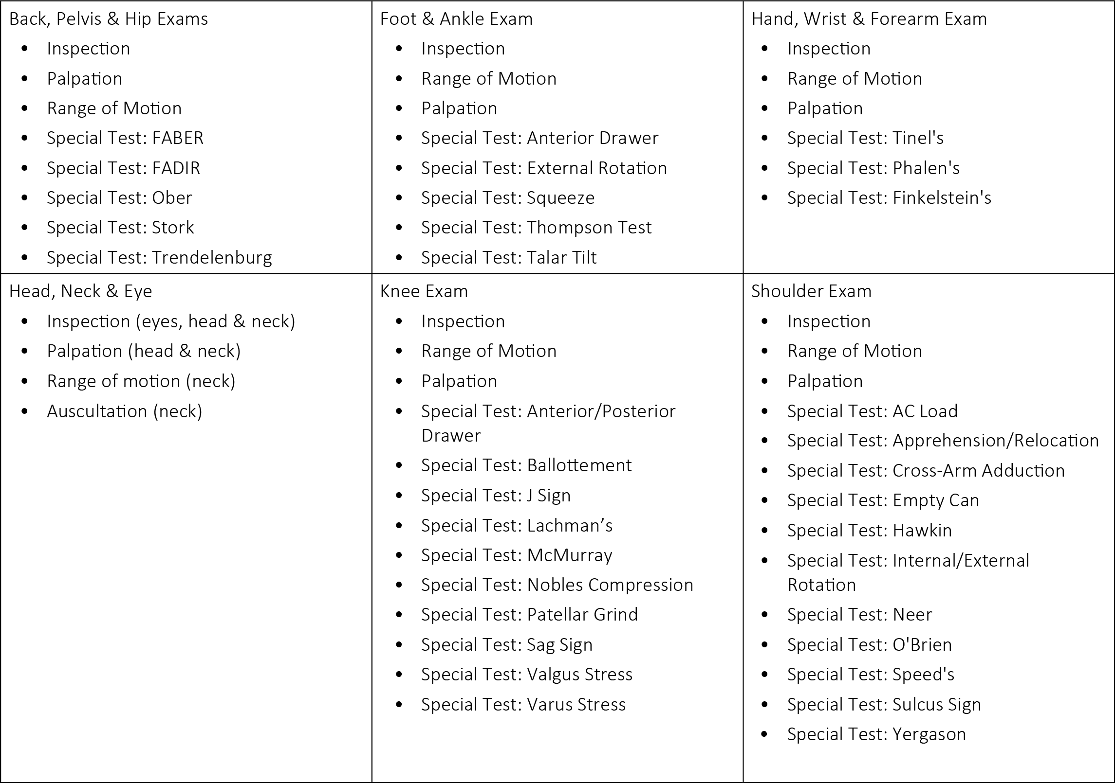

APPENDIX C: Non-Clinical Learning Experiences/Requirements

Social Determinants of Health Social Need Action Plan

All third-year medical students are required to complete a curriculum on public health. This curriculum builds on concepts learned throughout your medical education, culminating to your third year regarding the social determinants of health (SDOH). Taking a big picture approach, students will learn about the practice of public health and ways that family doctors and other primary care providers can play an important role in influencing population health. Students are to present their project to preceptors for feedback.

Goals of the SDOH Modules
- Review concepts around the social determinants of health (SDOH) and other non-medical factors that play important roles in patient health and well-being.
- Motivate the student to use this understanding to develop strategies for alleviating health disparities for individuals, their families and their communities.

SDOH Curriculum Objectives
- Develop an action plan of the case patient’s top three needs based upon a patient's social needs and identify resources in the patient's community to address their challenges.
- Take into account an understanding of non-biological factors when partnering with patients in treatment plans.

Practice-Based Learning & Improvement (PBLI) for Clinical Clerkships

All students are required to complete and submit a PBLI during their Family Medicine Clerkship rotation. For this assignment, students are to identify a patient during their rotation and develop a "clinical inquiry" based upon something that is unfamiliar. Clinical inquiries can be on therapy, diagnosis or screening, prognosis, etiology, harm and cost. Preceptors are not required to review these.

